|  |
| --- |
|  |
| [www.broughtonparishcouncil.org.uk](http://www.broughtonparishcouncil.org.uk) |
|  |

**Broughton in Amounderness Parish Council E-news Spring 2021 17th Edition**

**Cottage update**

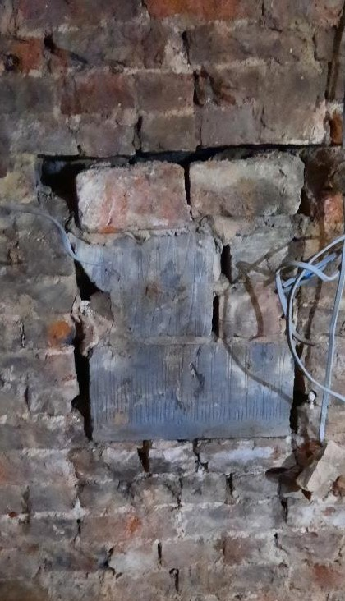

After removing the fireplace the original toll window has been revealed it will be rein sated. The original stone lintels around the fireplace have been revealed and will be cleaned. And the wood burning stove reinstated.

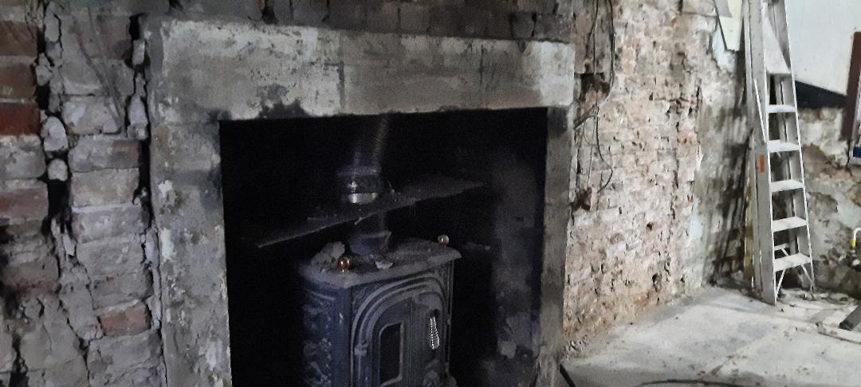

However this revealed that the damp course installed in the 1970’s in adequate. A membrane is being installed as a permanent solution. The front boundary wall is being built with recycled bricks form the garage and chimney. The work is now on track as the weather has improved.

**Café opening June 2021**

|  |
| --- |
|  |
| Important Announcement |

|  |
| --- |
|  |
| If have any comments or suggestions or wish it delivered please contact the Parish Clerk at: [clerk@broughtonparishcouncil.org.uk](mailto:clerk@broughtonparishcouncil.org.uk) or 40 Kings Drive, Fulwood, Preston PR2 3HP  Covid notices from HMG are published on our website |
|  |

**Traffic issues Broughton Update**

The **enforcement of the 20mph speed limit** has made no progress. Both LCC and the traffic police have been contacted and discussed this issue over the last two years with the result that neither body will agree to get it enforced. Further research suggested that this was an area of national interest and that the speed limits were enforced in a number of areas (including London) There are national campaign “**20 is plenty**” who’s campaign manager s is to promte the 20mph speed limits. She explaiend that the police have a duty ot enforce this speed limit and they are usually part of the process whenthe local authority when they are set up. She explained that if the police will not enforce it “3rd party reporting using head and dash cam evidence, this has made a massive difference to rates of crime reduction in London with two thirds of the 30,000 camera evidence files submitted are actioned. Another group Action Vision Zero analyis and compare data on the police stats on road danger for Lancashire which I have requested. Her colleague Jeremy Leach of Action Vision Zero advice was to contact the candidates for the police and crime commissioner for Lancashire for the May election and get their stance on this and then publish it. (This has been done)

The “SLOW” sign at the crossroads has not prevented a number of accidents and incidents. The PC has contacted LCC **to request a “STOP” sign** but this has been denied. The planning permission for the three story towner at the corner has been agreed which will further reduce the line of site.

The **Parking in the Village** has eased during lockdown. The signs for the car park have arrived and been collected by PCC who will erect them. It is hoped people may respect the 4 hour limit (this does not apply to the pre-school staff) and only use the car park when needed.

A letter was sent to all the schools empathising the point that when collecting pupils to park not blacking entrances, without engines running and not in no parking zones on the Garstang Road.

The situation on the Garstang Road will only get worse as the additional two apartments behind the education center have received planning permission. The PC objected to this development as there is no parking available for these apartments. The bay in front of the cottages can take five cars, there are four properties and number two Toll Bar Cottage that currently use this bay. The education center use the village car park (hopefully the chiropodist will as well ) but there is no provision for their staff. Across the road the short term bay is the only parking for those cottages which once the development at the crossroads is completed will have nowhere to park. The Gateway 55 + development at the crossroads has significantly less parking spaces than apartments. The PC welcome ideas to try ot alleviate the situation.

# Village round up

|  |
| --- |
|  |
| In the Community Residents are being consulted as to whether the center of the Village ( the red line) should be a **conservation area**.  C:\Users\Pat\Pictures\conservation area\Scan_20170302 (5)_LI.jpg  More details in the next edition of the e-news  **RIBA competition for a Mosque** on the Church Farm site https://www.blogpreston.co.uk/wp-content/uploads/2021/03/the-mosque-area-RIBA-720x532.jpg?x28593  As yet there has been NO application or planning permission for the development of this site on the LCC depot used for the building of the bypass. IF this project progresses to the planning application the design, capacity & parking will be the key issues for the PC to focus on |

**Police matters:** the police are aware of the issues with youths on the park and an empty property on Durton Lane. The contact for Broughton is: julie.anyon3@lancashire.pnn.police.uk

**Library bus** continues to visit Durton Lane, Sunningdale & Stanley

**Broughton Club** plan to on the 27th April start outdoor sports, on the 12th April outdoor eating & drinking & on the 17th May indoor activities

**Parish Council meetings continue by zoom at 7.30pm link available the week before: 13th April:** a representative form United Utilities will attend to answer questions about the closure of Woodplumpton Lane **17th May** Annual Parish Meeting & **6th July**