The Parish Council has been trying since the Village realm works were completed in 2019 to work with LCC & the LRSP to improve signage and educate drivers going through the village.

The ongoing issues with the crossroads in Broughton are only part of the traffic and parking issues that beset the Village but this press release deals specifically with the **crossroads**.

Today there has been yet another accident at the crossroads involving three cars. This is the latest in a large number of incidents but as they have not all been reported to the police there are no records to provide proof of the problem. To try to get help with this the Parish Council has been corresponding with LCC and the cabinet members for Highways and Transport since 2021

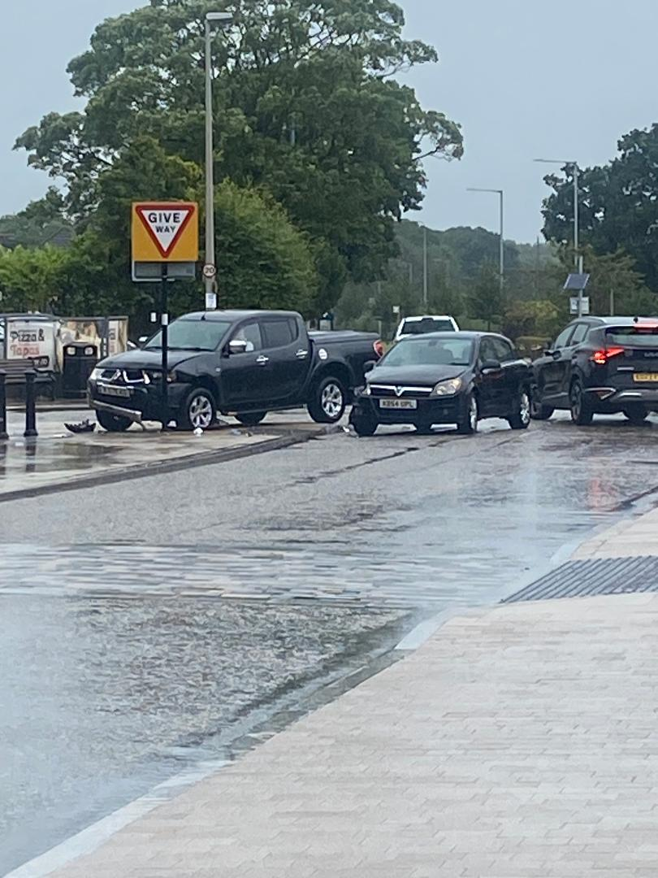 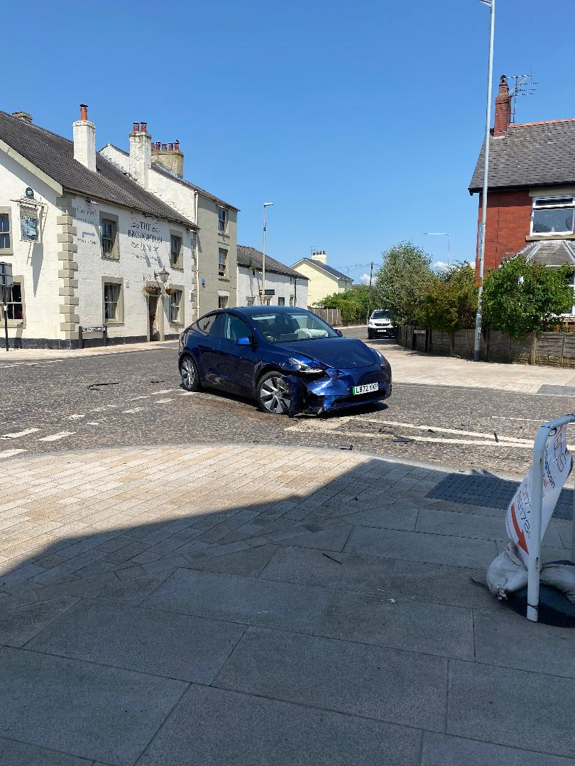

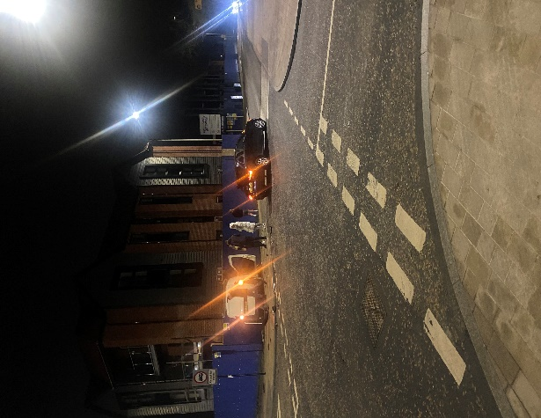 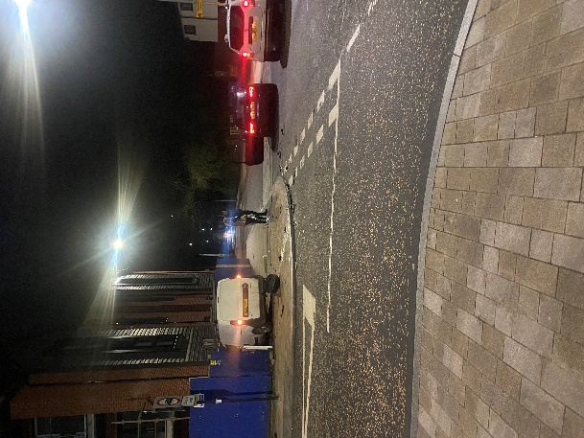

The letter we received in February this year was from Cllr Swarbrick which stated that:

* “We would l not support the introduction of stop signs at the corner. Department of Transport guidance makes it clear that these should only be provided at junctions with restricted visibility. As this does not apply to Broughton Crossroads we introduced “Give Way” signs instead. We also mounted these on yellow backing boards to improve visibility for approaching drivers”.
* The letter went on to say that **if** there was “evidence based speeding issue” the council would look “to introduce mitigation measures”. As there was no “evidence” the Parish Council purchased SPID’s to monitor this stretch of road. The data has now been with LCC for several months and we have had no response.
* The road apparently is suitable for a “variable message site” which has been installed in the spring/summer of 2023….the PC’s SPID’s do this already.

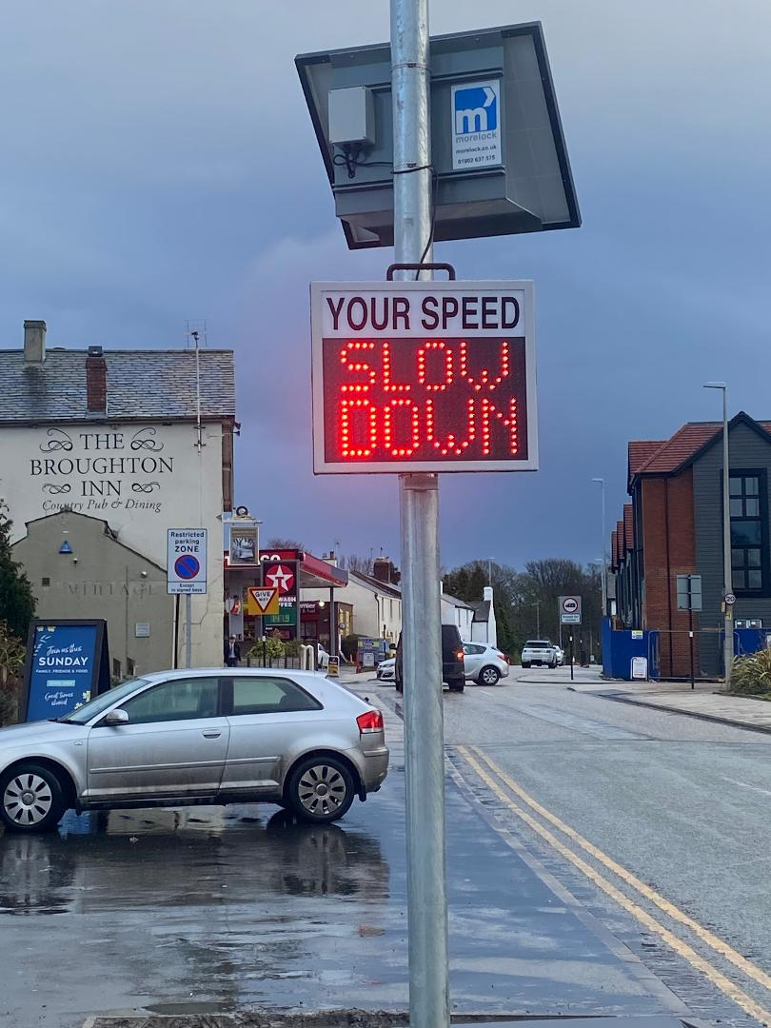

* They go on to say that they will install temporary signs from April to June and reinstall October to December to “maximise the effect of the message”. These signs have been in place for the last three months and are still there.

The Lancashire Road Safety Partnership trained pupils from Broughton High School to use speed monitoring equipment which they will utilise when the new term starts.

The crossroads are an area of particular concern as the new apartments for over 60’s restrict the line of site at the North West corner and the entrance is just to the west of the corner. As yet these premises are not occupied but once the 70 + residents and their vehicles are in place the situation will worsen.

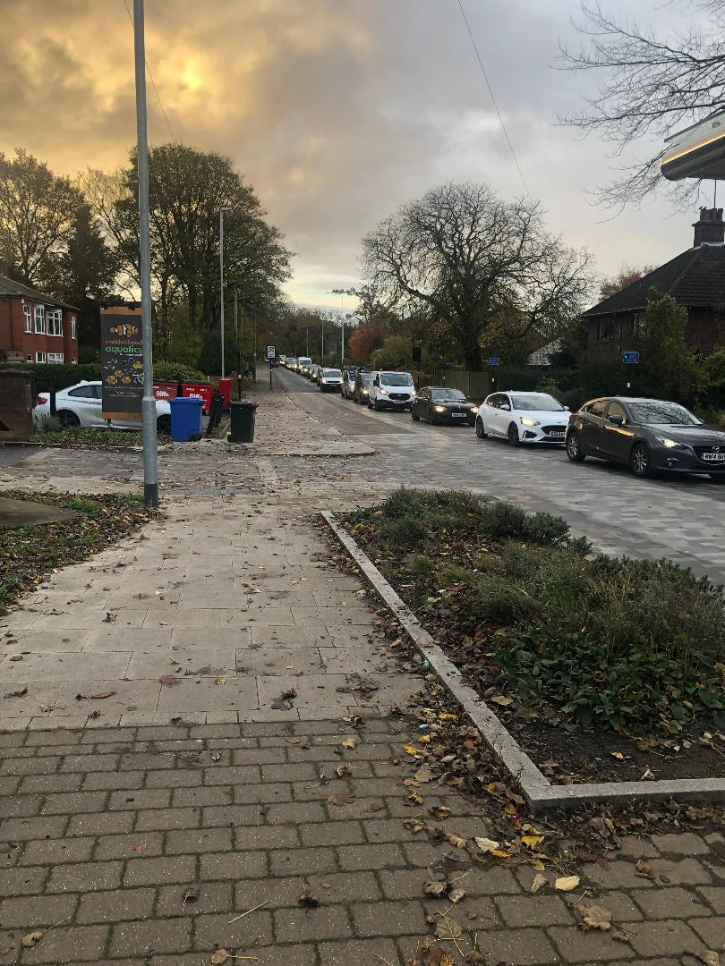

The Parish Council has been trying to get the LRSP/Police/LCC to implement the 20mph limit, our SPID’s show that the average speed through the cross roads is over 30mph.

The Parish Council has reported the issue to the Lancashire Road Safety Partnership as yet we have had no response and it looks like they are not going to. Last week its website stated that: “Due to the unprecedented number of speeding concerns we continue to receive relating to 20mph limits, we have made the difficult decision to pause the assessment of newly received 20mph limit concerns from the 1st July 2023 onwards, in order to concentrate on properly assessing and appropriately responding to existing 20mph limit concerns.”

The LEP reported that Freedom of Information requests to Lancashire Police show there has been no fixed penalties issues for speeding in 20mph zones for many years, and say that “numerous” reports about persistent speeding problems submitted to Lancashire County Council “seem to have fallen on deaf ears.”

So what can the Parish Council do?

* We can write to LCC/LRSP again…
* We have installed the SPID’s but need the data analysing…
* We can use Speed Monitoring equipment but if no one will issue penalty notices why bother!
* We have the support of our Cllrs & MP…
* We are member of the national 20 is plenty campaign…

PH/08/23