[](http://www.blackburn.anglican.org/more_info.asp?current_id=517)

THE PARISH OF ST. JOHN BAPTIST BROUGHTON

The Damaris Dixon Trust

Registered Charity Number 222925

***Donated in the Will of Damaris Dixon, dated 12th September 1895 to help alleviate conditions of need or distress of persons living within the Ecclesiastical Parish of Broughton St John Baptist***

**GUIDANCE NOTES**

**This Trust distributes grants to people who live in the Parochial Parish of Broughton,**

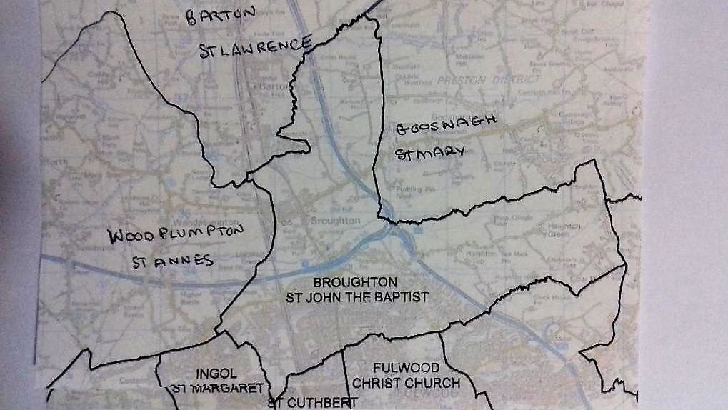

The grants are can be made to adults, children & families to help where others forms of assistance may not be available or may be needed speedily.

Examples of where they can be used are (this list is not finite, each case is treated on its merits):-

* Capital items such as furniture or white goods
* Capital items such as books or tools/equipment to help with a programme of study
* Travel expenses to relating to hospital visits or treatments
* The cost of homes adaptations or installation of telephones
* The provision of recreational equipment or training to improve wellbeing

Applications to the Trust should be on the Application form. The Application if made on behalf of a young person under 16 must be made by a responsible adult.

The Trust accepts applications all year around and aims to respond within 21 days of receipt.

The Damaris Dixon Trust

Registered Charity Number 222925

**APPLICATION FORM**

Name of Person making the Application

Applicant (if different from above)

Date of birth if under 16 years of age

Address (including post code)

Telephone Number Email Address

Request for assistance

Total Cost Amount of grant requested

Name & contact details of an independent Referee

Relationship to Applicant

*It should be noted that the decision of the Trustees is final and no further correspondence will be entered into.*

**Applications should be submitted to:**

Broughton Parish Office: St Martin’s House, Northway, Fulwood, Preston, Lancashire PR2 9TP

email: officebroughtonparish@gmail.com